Practical No:04
Programs related to different Layouts Coordinate, Linear, Relative, Table, Absolute, Frame, List View, Grid View.
1)Listview:
Code:
MainActivity.kt
package com.example.listdemo3p
import androidx.appcompat.app.AppCompatActivity
import android.os.Bundle
import android.widget.ArrayAdapter
import android.widget.Toast
import kotlinx.android.synthetic.main.activity_main.*
class MainActivity : AppCompatActivity() {
override fun onCreate(savedInstanceState: Bundle?) {
super.onCreate(savedInstanceState)
setContentView(R.layout.activity_main)
var data= arrayOf("Jan","Feb","March","April","May","June","July","August")
var adapt=ArrayAdapter (this,android.R.layout.simple_list_item_1,data)
list_view1.adapter=adapt
list_view1.setOnItemClickListener { adapterView, view, i, l ->
var d=adapterView.getItemAtPosition(i).toString()
Toast(this,)
}
}
}
Output:
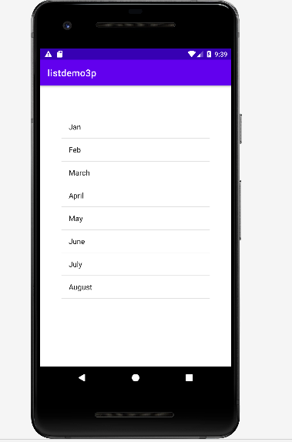

2)Linear ,table:
Code:
activity_main.xml
<?xml version="1.0" encoding="utf-8"?>
<LinearLayout xmlns:android="http://schemas.android.com/apk/res/android"
xmlns:app="http://schemas.android.com/apk/res-auto"
xmlns:tools="http://schemas.android.com/tools"
android:layout_width="match_parent"
android:layout_height="match_parent"
android:orientation="vertical"
tools:context=".MainActivity"
>
<TableLayout
android:layout_width="match_parent"
android:layout_height="wrap_content"
android:layout_margin="10dp"
>
<TextView
android:id="@+id/res"
android:layout_width="match_parent"
android:layout_height="50dp"
android:text=""
android:textSize="40dp"
android:gravity="right"
/>
<TableRow android:padding="2dp">
<Button
android:id="@+id/modulo"
android:text="%"/>
<Button
android:id="@+id/ce"
android:text="CE"
android:layout_marginLeft="10dp"/>
<Button
android:id="@+id/ac"
android:text="AC"
android:layout_marginLeft="10dp"/>
<Button
android:id="@+id/clear"
android:text="Clear"
android:layout_marginLeft="10dp"/>
</TableRow>
<TableRow android:padding="2dp">
<Button
android:id="@+id/one"
android:text="1"/>
<Button
android:id="@+id/two"
android:text="2"
android:layout_marginLeft="10dp"/>
<Button
android:id="@+id/three"
android:text="3"
android:layout_marginLeft="10dp"/>
<Button
android:id="@+id/add"
android:text="+"
android:layout_marginLeft="10dp"/>
</TableRow>
<TableRow>
<Button
android:id="@+id/four"
android:text="4"/>
<Button
android:id="@+id/five"
android:text="5"
android:layout_marginLeft="10dp"/>
<Button
android:id="@+id/six"
android:text="6"
android:layout_marginLeft="10dp"/>
<Button
android:id="@+id/sub"
android:text="-"
android:layout_marginLeft="10dp"/>
</TableRow>
<TableRow android:padding="2dp">
<Button
android:id="@+id/seven"
android:text="7"/>
<Button
android:id="@+id/eight"
android:text="8"
android:layout_marginLeft="10dp"/>
<Button
android:id="@+id/nine"
android:text="9"
android:layout_marginLeft="10dp"/>
<Button
android:id="@+id/mul"
android:text="X"
android:layout_marginLeft="10dp"/>
</TableRow>
<TableRow android:padding="2dp">
<Button
android:id="@+id/zero"
android:text="0"/>
<Button
android:id="@+id/point"
android:text="."
android:layout_marginLeft="10dp"/>
<Button
android:id="@+id/equal"
android:text="="
android:layout_marginLeft="10dp"/>
<Button
android:id="@+id/div"
android:text="/"
android:layout_marginLeft="10dp"/>
</TableRow>
</TableLayout>
</LinearLayout>

activity_main.xml
<?xml version="1.0" encoding="utf-8"?>
<LinearLayout xmlns:android="http://schemas.android.com/apk/res/android"
xmlns:app="http://schemas.android.com/apk/res-auto"
xmlns:tools="http://schemas.android.com/tools"
android:layout_width="match_parent"
android:layout_height="match_parent"
android:orientation="vertical"
tools:context=".MainActivity"
>
<TableLayout
android:layout_width="match_parent"
android:layout_height="wrap_content"
android:layout_margin="10dp"
>
<TextView
android:id="@+id/res"
android:layout_width="match_parent"
android:layout_height="50dp"
android:text=""
android:textSize="40dp"
android:gravity="right"
/>
<TableRow android:padding="2dp">
<Button
android:id="@+id/modulo"
android:text="%"/>
<Button
android:id="@+id/ce"
android:text="CE"
android:layout_marginLeft="10dp"/>
<Button
android:id="@+id/ac"
android:text="AC"
android:layout_marginLeft="10dp"/>
<Button
android:id="@+id/clear"
android:text="Clear"
android:layout_marginLeft="10dp"/>
</TableRow>
<TableRow android:padding="2dp">
<Button
android:id="@+id/one"
android:text="1"/>
<Button
android:id="@+id/two"
android:text="2"
android:layout_marginLeft="10dp"/>
<Button
android:id="@+id/three"
android:text="3"
android:layout_marginLeft="10dp"/>
<Button
android:id="@+id/add"
android:text="+"
android:layout_marginLeft="10dp"/>
</TableRow>
<TableRow>
<Button
android:id="@+id/four"
android:text="4"/>
<Button
android:id="@+id/five"
android:text="5"
android:layout_marginLeft="10dp"/>
<Button
android:id="@+id/six"
android:text="6"
android:layout_marginLeft="10dp"/>
<Button
android:id="@+id/sub"
android:text="-"
android:layout_marginLeft="10dp"/>
</TableRow>
<TableRow android:padding="2dp">
<Button
android:id="@+id/seven"
android:text="7"/>
<Button
android:id="@+id/eight"
android:text="8"
android:layout_marginLeft="10dp"/>
<Button
android:id="@+id/nine"
android:text="9"
android:layout_marginLeft="10dp"/>
<Button
android:id="@+id/mul"
android:text="X"
android:layout_marginLeft="10dp"/>
</TableRow>
<TableRow android:padding="2dp">
<Button
android:id="@+id/zero"
android:text="0"/>
<Button
android:id="@+id/point"
android:text="."
android:layout_marginLeft="10dp"/>
<Button
android:id="@+id/equal"
android:text="="
android:layout_marginLeft="10dp"/>
<Button
android:id="@+id/div"
android:text="/"
android:layout_marginLeft="10dp"/>
</TableRow>
</TableLayout>
</LinearLayout>

Output:
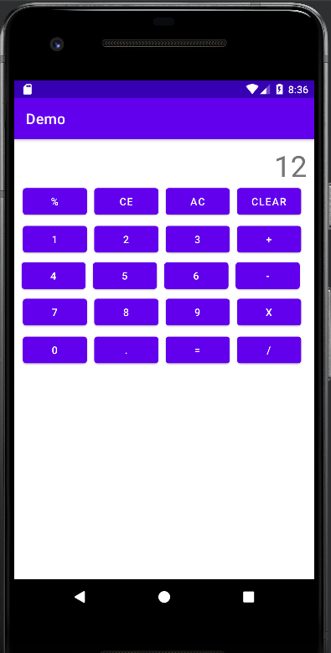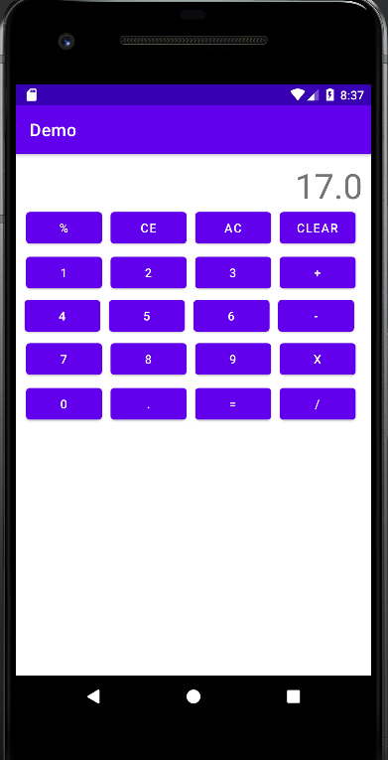

3)Frame:
For Multiple Fragment:
Code:
mainActivity file:
package srm.it.fragmentdemo
import androidx.appcompat.app.AppCompatActivity
import android.os.Bundle
import kotlinx.android.synthetic.main.activity_main.*
class MainActivity : AppCompatActivity() {
override fun onCreate(savedInstanceState: Bundle?) {
super.onCreate(savedInstanceState)
setContentView(R.layout.activity_main)
var state=0
button.setOnClickListener {
if(state==0) {
supportFragmentManager.beginTransaction().replace(R.id.fragmentContainerView,first()).commit()
state=1
}
else{ supportFragmentManager.beginTransaction().replace(R.id.fragmentContainerView,second()).commit()
state=0
} } } }
first Fragment:
package srm.it.fragmentdemo
import android.os.Bundle
import androidx.fragment.app.Fragment
import android.view.LayoutInflater
import android.view.View
import android.view.ViewGroup
import android.widget.Toast
import kotlinx.android.synthetic.main.fragment_first.*
import kotlinx.android.synthetic.main.fragment_first.view.*
class first : Fragment() {
override fun onCreate(savedInstanceState: Bundle?) {
super.onCreate(savedInstanceState)
}
override fun onCreateView(
inflater: LayoutInflater, container: ViewGroup?,
savedInstanceState: Bundle?
): View? {
var root=inflater.inflate(R.layout.fragment_first, container, false)
root.button2.setOnClickListener {
Toast.makeText(context,"Fragment One",Toast.LENGTH_LONG).show()
}
return root
} }
second Fragment:
package srm.it.fragmentdemo
import android.os.Bundle
import androidx.fragment.app.Fragment
import android.view.LayoutInflater
import android.view.View
import android.view.ViewGroup
import android.widget.Toast
import kotlinx.android.synthetic.main.fragment_second.*
import kotlinx.android.synthetic.main.fragment_second.view.*
class second : Fragment() {
override fun onCreate(savedInstanceState: Bundle?) {
super.onCreate(savedInstanceState)
}
override fun onCreateView(
inflater: LayoutInflater, container: ViewGroup?,
savedInstanceState: Bundle?
): View? {
var root=inflater.inflate(R.layout.fragment_second, container, false)
root.button3.setOnClickListener {
Toast.makeText(context,"Fragment Second",Toast.LENGTH_LONG).show()
}
return root
} }
Output:
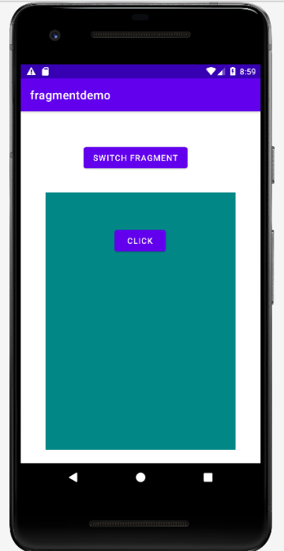
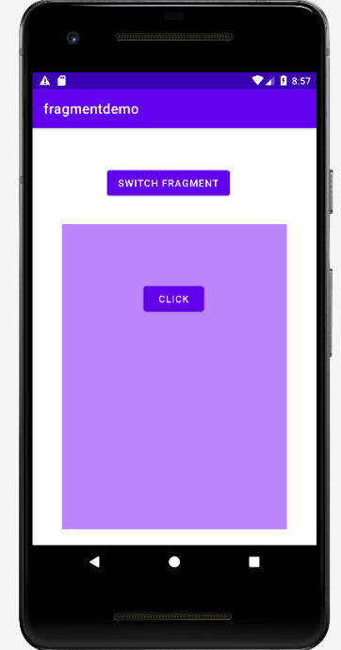
First Fragment: second Fragment:

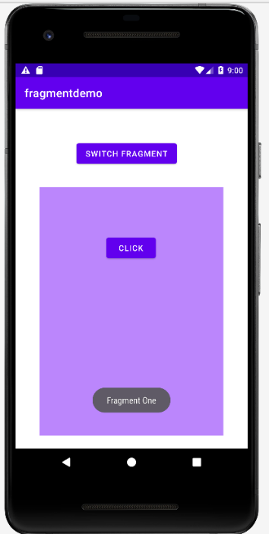
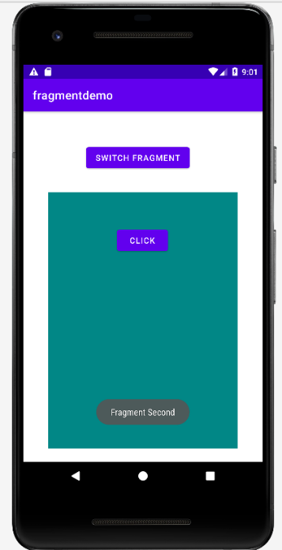
Inside firstFragment: Inside secondFragment :

